Spring boot with Reactive programming

1. Eureka Server

Starter 🡪Web

Starter 🡪Eureka

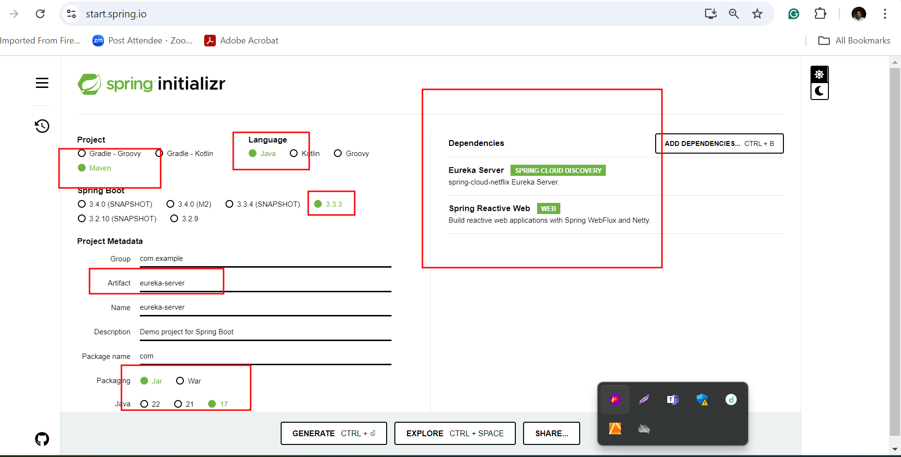

1. Creating reactive employee end point

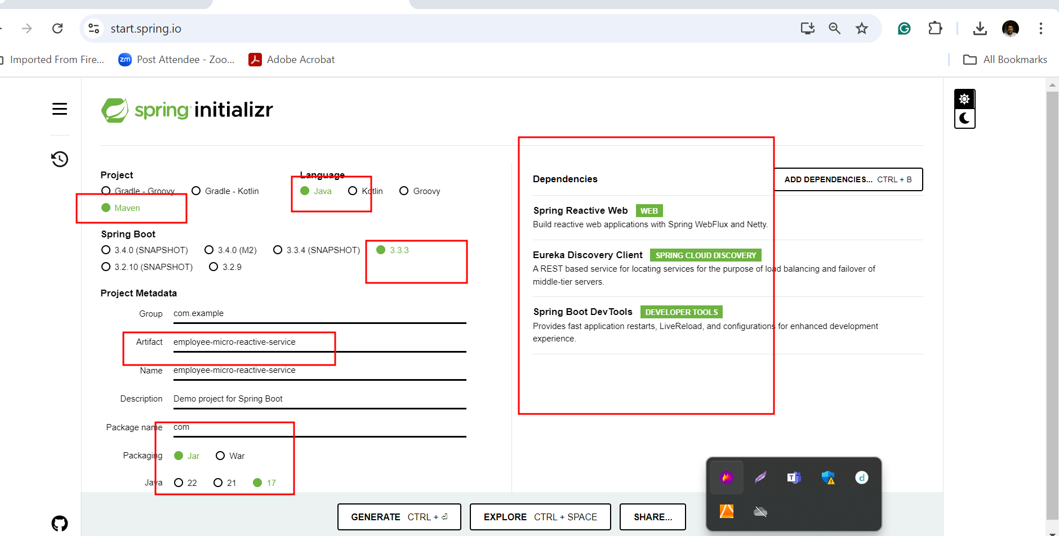

1. Creating reactive micro service interact with db ie mysql

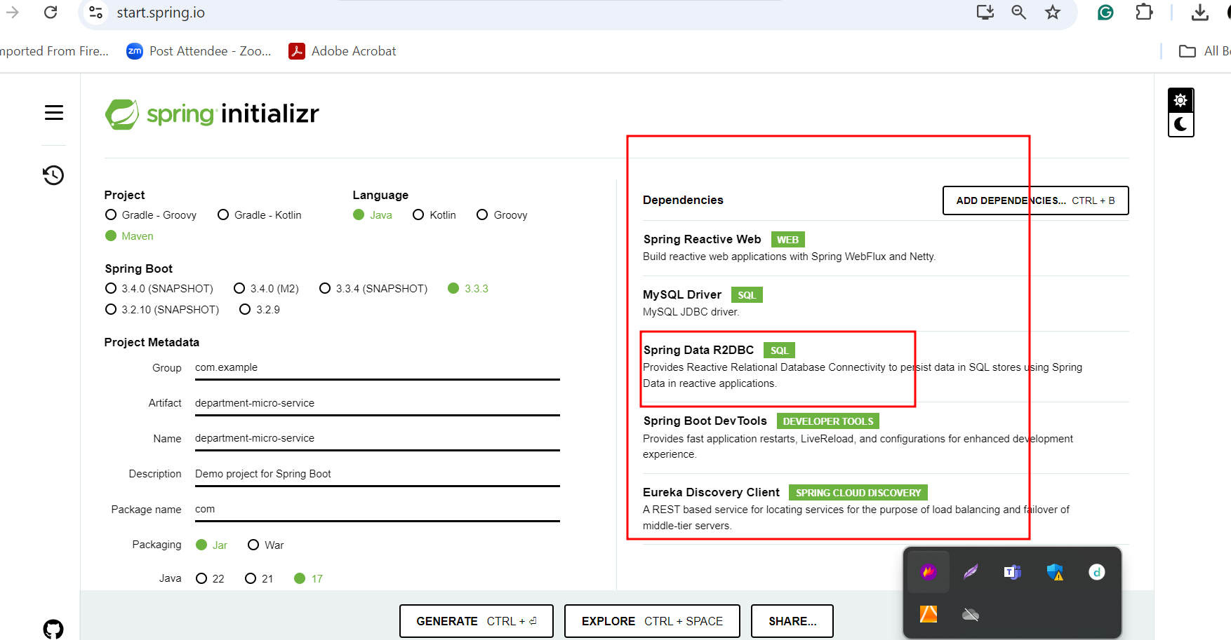

Creating employee with db micro service going to communicate with department micro service to get the department details.

In Reactive web flux we need to use WebClient to call another micro service

RestRemplate for synchronous communication

WebClient for asynchronous communication